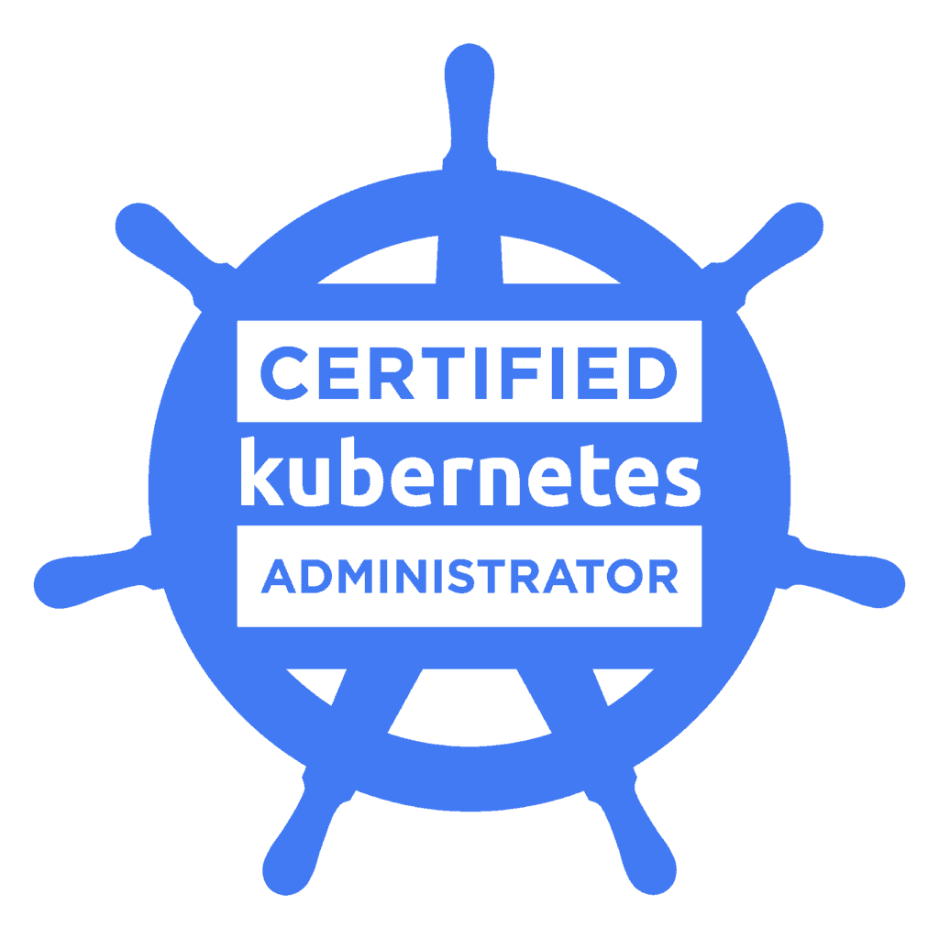
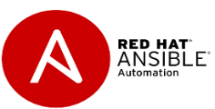
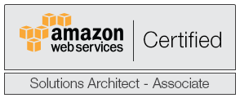
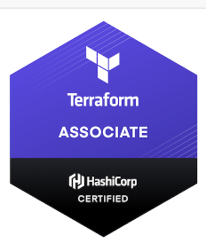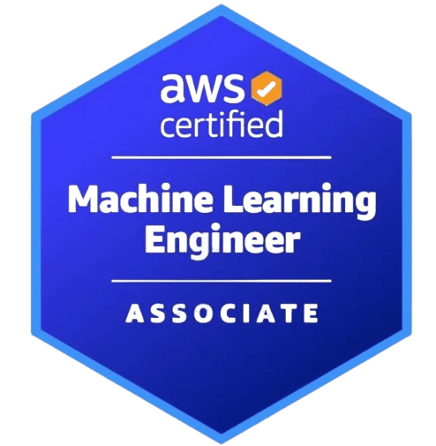

Name: Gopinath Reddy

Phone:248-243-2506

Email: gopi85narayan@gmail.com
LinkedIn - linkedin.com/in/gopinath-narayan-he-him-his-3b9856127

SUMMARY OF PROFILE
- passionate Cloud DevOps Engineer with 9+ years of IT experience, specializing in AWS DevOps for 7+ years. I have also gained 2 years of experience in Java J2EE. Throughout my career, I have worked with industry-leading organizations like U.S. Department of Veterans Affairs ,Ally Financial, Ford, Federal, and Wells Fargo, driving DevOps transformations and implementing IaaS/PaaS solutions. I excel in developing large-scale application architectures to meet complex business requirements and thrive in fostering a culture of excellence through collaborative relationships with stakeholders at all levels
- Experienced in AWS Cloud platform which includes EC2, VPC,ECS,EKS, EBS, AMI, SNS, RDS, EBS,ALB Cloud Watch, Cloud Trail, Cloud Formation, AWS Config,AWS Glue, Auto Scaling, CloudFront, IAM, S3 and Route53, DynamoDB Gateway, DynamoDB,Lambda
- Hands-on experience with BigQuery for building analytical queries, optimizing performance, and managing large datasets
- Developed and deployed secure GCP infrastructure using Terraform to support data protection APIs across development and staging environments, ensuring compliance with industry security standards.
- Experience in developing and maintaining data pipelines using Apache Kafka and Google Cloud Dataflow (Apache Beam).
- Strong knowledge of Google Cloud Data Fusion for building scalable ETL/ELT pipelines with both batch and streaming integrations.
- Skilled in managing distributed computing workloads using Google Dataproc (Apache Spark and Hadoop).
- Experience in orchestrating data workflows and pipeline scheduling using Cloud Composer (optional but helpful).
- Built and maintained Jenkins CI/CD pipelines for automated deployment of microservices related to data protection and audit logging, reducing deployment time and improving developer productivity.
- Designed and maintained ETL pipelines using Informatica and IBM DataStage to extract, transform, and load structured and semi-structured data from multiple sources into enterprise data warehouses.
- Developed interactive dashboards and reports in Power BI, enabling business stakeholders to gain actionable insights from large-scale datasets.
- Integrated Power BI with Azure Analysis Services, REST APIs, and cloud-based data lakes to support advanced analytics and KPI reporting.
- Designed infrastructure-as-code modules in Terraform for managing IAM policies, service accounts, and secure networking (VPCs, subnets, firewall rules) on GCP to protect sensitive vehicle and user data.
- Integrated Postman-based API test collections into Jenkins pipelines to automatically validate data protection endpoints post-deployment, ensuring service reliability and secure access.
- Implemented GCP-native security features such as VPC Service Controls, Cloud IAM, and Secrets Manager to isolate services and manage API secrets securely in compliance with automotive security standards.
- Monitored API access and data flow using Cloud Audit Logs and Cloud Logging to detect anomalies and support security audits as part of the vehicle data governance policy.
- Developed automated Terraform scripts to provision Pub/Sub topics and GCS buckets with CMEK (Customer Managed Encryption Keys) for secure transmission and storage of vehicle telemetry data.
- Strong knowledge of Google Cloud Platform (GCP) including Compute Engine, Cloud Storage, VPC, IAM, GKE, Cloud Functions, Pubsub, Cloud Run, Cloud Build, Cloud SQL, BigQuery, and Stackdriver (Cloud Monitoring & Logging), with solid understanding of networking, security, and resource management best practices.
- Designed and developed interactive dashboards and reports in Power BI, integrating data from GCP sources such as BigQuery and Cloud SQL.
- Expertise in Power BI DAX expressions, Power Query (M), and data modeling to support self-service analytics and executive-level reporting.
- Created data visualizations and KPI dashboards tailored to business needs across finance, operations, and marketing domains.
- Experienced in working on DevOps/Agile operations process and tools area (Code review, unit test automation, Build and Release automation, Environment, Service, Incident and charge Management).
- Active participant in pair programming sessions, promoting knowledge sharing, collaborative debugging, and real-time code review.
- Advocated for Agile/Scrum practices, including code reviews, TDD, CI/CD pipelines, and sprint planning.
- Used Git and DevOps workflows (e.g., GitHub, GitLab, Bitbucket) for version control and collaboration in cross-functional teams.
- Team Collaboration –As a good team player worked with different teams developers and project managers, business analysts, testers, and multi-location teams

TECHNICAL SKILLS

Cloud Computing: AWS (EC2, VPC,EKS,ECS, ELB, S3,ALB, EKS, Cloud Trail and Route 53), IBM Cloud IKS.

CI & Automation: Jenkins, Ansible, Terraform.

Application Servers: JBoss application servers 6.2.x, 6.4, Oracle WebLogic Server 11g/12c, IBM WebSphere.

Web Servers: IBM HTTP Server6.1, Apache Server 1.3.x/ 2.0.x, IIS Manager 7, Tomcat.

Monitoring Tools: Heap Analyzer, log Analyzer, AWS CloudWatch CloudTrail, Splunk, Dynatrace.

Scripting: UNIX shell scripting, JSON, Python.

Database Oracle: 8i/9i/10g, SQL Server 2000/2003/2005/2008.

Operating Systems: Windows 2000/2003XP/Vista, RED HAT LINUX, Fedora LINUX, SO

Security & Others: SiteMinder, iKeyman, LDAP, Introscope.

Protocols: FTP, SFTP, HTTP, HTTPS, AS2, TCP/IP, SOAP.
- ETL Tools: Informatica PowerCenter, IBM DataStage
- BI & Reporting: Power BI, QlikView/Qlik Sense, Looker

EDUCATION

Master’s degree in computer science, California State University, CA 2015

Bachelor of Technology degree in Computer science, Jawaharlal Nehru Technological University, India, 2012

CERTIFICATIONS

AWS Certified – Solutions Architect – Associate, 2019

Red Hat Certified Specialist in Ansible Automation 2019

Terraform Associate certified-2020

Certified Kubernetes Administrator -2021

Google Cloud Platform Fundamentals: Core Infrastructure –course certificate

AWS Machine Learning Associate Certified -2025

PROFESSIONAL EXPERIENCE

U.S. Department of Veterans Affairs, Detroit, MI Oct 2023-Present

Sr. Cloud DevOps Engineer

Environment:GCP,Terraform,Terragrunt,Jenkins,Ansible,GitHub,Kubernetes,ArgoCD,Grafana,Docker,OpenShift,Splunk,Python

Responsibilities

Managed GCP services like Compute Engine, Cloud Storage, IAM, Cloud SQL, Cloud Monitoring, and GKE to support mission-critical application infrastructure.

Automated infrastructure provisioning using Terraform and Deployment Manager for reproducible, secure deployments.

Investigated and resolved issues with GCP services including networking (VPC, subnets, route tables, firewall rules) and IAM permissions.

Built and maintained automated Jenkins CI/CD pipelines for continuous integration, test automation, and deployment of critical federal healthcare applications.

Integrated Jenkins with Cloud Source Repositories, SonarQube, Nexus, and Ansible to build a secure, compliant DevSecOps pipeline.

Collaborated with data engineering and DevOps teams to automate ETL deployments and BigQuery report refresh schedules using CI/CD pipelines and Python scripting.

Applied RBAC policies and secret management (e.g., Secret Manager, HashiCorp Vault) within Jenkins to meet federal compliance requirements.
• Worked with GCP technologies such as Cloud BigQuery, Cloud Dataproc, Cloud Dataflow, Cloud Data Fusion, Dialog flow and Speech API

Worked closely with security and compliance teams to support ATO (Authority to Operate) for CI/CD tooling and Kubernetes infrastructure.

Managed deployment and lifecycle of containerized applications in Google Kubernetes Engine (GKE) and on-prem clusters, ensuring availability and compliance with VA healthcare standards.

Implemented Helm charts for repeatable, environment-specific deployments (dev/stage/prod) across cloud-native systems.

Configured RBAC, network policies, workload identity, and namespace isolation for federal-grade Kubernetes security.

Executed rolling updates, canary deployments, and blue-green deployments using Argo CD and native Kubernetes methods.

Enabled centralized logging and observability with Cloud Logging, Cloud Monitoring, Prometheus, and Fluentd for real-time system insights.

Used Terraform and Ansible to provision and configure Jenkins workers, GKE clusters, and supporting infrastructure components.

Ensured high availability via GCP load balancing (HTTP/S, TCP/SSL), autoscaling, and multi-zone deployments.

Integrated Cloud Monitoring and Cloud Pub/Sub for event-driven alerting and automated notifications.

Collaborated with app teams to troubleshoot Jenkins pipeline failures and Kubernetes cluster issues during live incidents.

Utilized observability tools like Splunk, Cloud Logging, and OpenSearch to analyze logs and reduce MTTR.

Supported GCP infrastructure, including Compute Engine, IAM, VPC, and GKE troubleshooting in a federal environment.

Delivered 24/7 SRE support in rotation, ensuring uptime, incident response, and operational continuity for mission-critical services.

Performed weekly code deployments and change control for federal programs, including code promotion from dev to production.

Engaged in on-call rotations and led triage efforts during high-severity incidents across GCP-hosted services.

Developed and maintained Jenkins pipelines for automated builds, tests, and deployments across staging and production.

Integrated Jenkins with GCP-native tools, GitHub Enterprise, SonarQube, and Nexus to streamline development workflows.

Troubleshot issues in Pods, Deployments, Services, Ingress, and NodePools across cloud and hybrid Kubernetes environments.

Implemented Secrets, ConfigMaps, NetworkPolicies, and Workload Identity Federation for organized and secure Kubernetes configurations.

Scaled GKE clusters using taints, tolerations, node affinity, and node auto-provisioning for efficient resource utilization.

Used kubectl, Stackdriver (Ops Suite), and Prometheus dashboards for live cluster monitoring, debugging, and performance tuning.

Ally, Detroit, MI Jan 2021 – Oct 2023

Sr. AWS Cloud| DevOps Engineer

Environment: AWS, Terraform, Jenkins, Ansible, Gitlab, Kubernetees,Docker OpenShift ,Splunk,

Python.

Responsibilities

Implemented infrastructure solutions using Terraform to provision and manage resources such as EC2, EKS, ECS, S3, RDS, ALB, EBS, Elastic Load Balancer, Auto Scaling Groups, Auto Scaling Launch Configuration, and Auto Scaling Lifecycle Hooks

Utilized automation tools such as Terraform, Ansible, Python, and Bash Scripts to work on AWS EC2, VPC, S3, SQS, and SNS, enabling efficient provisioning and management of infrastructure resources

Acted as a release manager, responsible for approving code in Infrastructure as Code (IAC) using Terraform and Ansible Playbooks for AWS infrastructure.

Worked extensively with Jenkins CI/CD pipelines, ensuring end-to-end automation for building, testing, and delivering artifacts. Resolved any build issues that arose during the Jenkins build process

Utilized Terraform for efficient management of infrastructure through terminal sessions. Executed scripts to create alarms and notifications for EC2 instances using AWS CloudWatch. Additionally, authored Ansible Playbooks for various applications and deployed them in AWS using Terraform.

Took charge of setting up lifecycle policies to facilitate data backups from AWS S3 to AWS Glacier, ensuring effective data management.

Played a key role in the creation, utilization, and management of policies and Glacier storage in S3 buckets on the AWS platformCreated Python scripts to automate AWS services which include web servers.

Utilized Terraform, Ansible, Python, and Bash scripts for automation of AWS EC2, VPC, S3, SQS, and SNS.

Developed Terraform modules for automating the creation of VPCs and launching AWS EC2 instances. Created modules for VPC creation, VPN connections from the data center to the production environment, and cross-account VPC peering.

Worked on Jenkins CI/CD pipeline jobs to automate the end-to-end build, testing, and delivery of artifacts, as well as troubleshooting build issues.

Defined AWS Security Groups as firewalls to control inbound and outbound traffic for AWS EC2 instances.

Set up lifecycle policies to migrate data from AWS S3 to AWS Glacier for long-term storage.

Managed AWS policies and utilized Glacier storage in S3 buckets.

Developed Python scripts to automate AWS services, including web servers.

Configured IAM Users/Roles/Groups/Policies and automated database and application backups to S3 using AWS CLI.

Implemented VPC services for on-premises data centers using AWS, VPC, and VPN services.

Leveraged OpenShift to enhance application security by deploying admin consoles on separate Docker containers accessible only through non-standard port numbers.

Configured NFS servers as OpenShift storage backends and handled various storage claims for developers.

Acted as a liaison between partner and development teams during migration to the OpenShift platform to foster positive rapport and collaboration.

Implemented solutions using EC2, S3, and RDS in CloudFormation JSON templates, along with EBS, Elastic Load Balancer, Auto Scaling Groups, Auto Scaling Launch Configuration, and Auto Scaling Lifecycle Hooks.

Worked on Jenkins CI/CD pipeline jobs for end-to-end automation, including building, testing, and delivering artifacts, as well as troubleshooting build issues.

Ford Motor Company,Dearborn,MI Jan 2020 – Dec 2020

Sr Cloud DevOps Engineer

Environment: AWS,vRealize VrA7 , Terraform, Jenkins, GitLab, Ansible, Chef, Python, Splunk.

OpenShift

Responsibilities

Developed and deployed secure GCP infrastructure using Terraform to support data protection APIs across development and staging environments, ensuring compliance with industry security standards.

Built and maintained Jenkins CI/CD pipelines for automated deployment of microservices related to data protection and audit logging, reducing deployment time and improving developer productivity.

Designed infrastructure-as-code modules in Terraform for managing IAM policies, service accounts, and secure networking (VPCs, subnets, firewall rules) on GCP to protect sensitive vehicle and user data.

Integrated Postman-based API test collections into Jenkins pipelines to automatically validate data protection endpoints post-deployment, ensuring service reliability and secure access.

Implemented GCP-native security features such as VPC Service Controls, Cloud IAM, and Secrets Manager to isolate services and manage API secrets securely in compliance with automotive security standards.

Monitored API access and data flow using Cloud Audit Logs and Cloud Logging to detect anomalies and support security audits as part of the vehicle data governance policy.

Collaborated with developers and InfoSec team to establish secure CI/CD practices for automotive APIs, leveraging Artifact Registry and Binary Authorization for signed, trusted deployments.

Implemented end-to-end CI/CD pipelines for API environments, building them from scratch using tools like Git, Jenkins, Ansible, Docker, Terraform, and CloudFormation.

Implemented Ansible for configuration management and can write playbooks from scratch.

Managed DNS systems using BIND and Route53 (AWS) for efficient domain management.

Provided oversight for designing and executing cloud-based architecture on AWS and Azure, including deployment orchestration and infrastructure adaptation.

Managed AWS EC2 instances utilizing Auto Scaling, Elastic Load Balancing, and Glacier for QA and UAT environments.

Implemented data integrity and security measures on AWS, designing backup and disaster recovery protocols for high up time.

Integrated Jenkins with tools like GIT, Bitbucket, Artifactory, Ansible, Docker, and AWS to establish robust CI/CD pipelines.

Utilized MongoDB as a database for storing API-related data.

Designed and implemented IaaS/SaaS infrastructure using infrastructure-as-code (IaC) practices and automated environment provisioning using VPCs and CloudFormation templates.

Developed CICD planning roadmaps and architecture diagrams for data protection and data storage teams in Ford VMs (Data Centers).

Implemented Terraform for infrastructure as code (IaC) on VMware, creating, testing, and deploying OpenShift YAML files for stateful application components.

Implemented Ansible Towers for specific applications from scratch.

Implemented monitoring and metrics for OpenShift containers using native and third-party products.

Worked with developers and operational teams to understand pipeline requirements and implement CI/CD pipelines effectively.

Acted as a Release Manager, conducting code reviews before production releases for multiple applications.

Implemented multiple pipelines for data storage and data protection in VMWare environments.

Collaborated with managers and directors to plan and implement DevOps practices, CICD tools, and cost planning.

Accenture Federal Services Apr 2019 – Dec 2019

Sr. AWS KAFKA Cloud|DevOps Engineer

Environment: Amazon Web Services (AWS) and On-Prem, Docker, Terraform, Ansible, Kafka,

Splunk

Responsibilities

Responsible for writing Terraform modules to automate the creation of VPCs and launch AWS EC2 instances. Modules were created for VPC and VPN connection establishment between the data center and production environment, as well as for cross-account VPC peering.

Worked with Kafka on AWS clusters, leveraging its capabilities for efficient messaging and data processing.

Developed Ansible playbooks for messaging using Kafka in AWS, enhancing automation and deployment processes.

Proficient in continuous integration and deployment planning and execution, utilizing Git, Jenkins, Ansible, Docker, Terraform, and CloudFormation.

Automated infrastructure provisioning on AWS using Terraform and Ansible, implementing nightly builds integrated with code quality tools like SonarQube.

Utilized Terraform for infrastructure management, configuring alarms and notifications for EC2 instances using AWS CloudWatch. Developed Ansible Playbooks for various applications and deployed them on AWS using Terraform.

Developed Ansible playbooks for application-specific build and deployment, creating reusable roles for streamlined deployment processes.

Worked with middleware application servers like JBoss and Kafka, integrating configuration and deployment using Jenkins for CI/CD and Ansible for code deployment.

Developed Jenkins pipeline jobs for build and deploy, implementing No Downtime Deployments (NDD) to ensure continuous application availability.

Created Ansible playbooks and roles for installing and upgrading Tivoli Workload Scheduler, optimizing task scheduling and management.

Troubleshot issues and monitored logs using Splunk, ensuring system stability and performance.

Automated Kafka monitor agent using Bash scripts, scheduling it to run every 60 minutes.

Utilized Ansible playbooks for messaging using Kafka in AWS, enhancing automation and efficiency in messaging processes.

Ford Motor Company, Dearborn, MI Jan 2017 – Mar 2019

Cloud DevOps Engineer- Application Management and Development

Environment: AWS, Jenkins, AccuRev, Nexus, SonarQube.

Responsibilities

Collaborated as a part of the DevOps team to ensure timely delivery of releases into the production environment. Worked closely with team members and project teams utilizing tools like Jenkins, Accurev, uBuild, Nexus, and SonarQube.

Responsible for the build and deployment of applications across different environments, including Development (Dev), Quality Assurance (QA), and User Acceptance Testing (UAT).

Installed, configured, and maintained Continuous Integration, Automation, and Configuration Management tools such as Accurev, uBuild, Nexus, SonarQube, and iRise.

Worked in an agile development team to deliver end-to-end continuous integration/continuous delivery solutions in an open-source environment, utilizing Chef and Jenkins.

Managed the installation, configuration, design, and administration of Jenkins Continuous Integration Server, integrating it with other systems and tools.

Implemented a continuous integration system using Gradle, Jenkins, and streamlined deployment processes for faster and error-free deployments.

Integrated Jenkins with tools like GIT, Bitbucket, Artifactory, and Chef to establish efficient CI/CD pipelines.

Developed Python scripts for deploying applications, building scripts, and automating various tasks.

Created Jenkins Workflows for pre-deployment processes, such as database execution and environment configuration changes, in QA and pre-production environments.

Developed automated scripts for SonarQube, deployment, maintenance, and related tasks.

Administered, maintained, and provided support for SonarQube, CA Agile Central (Rally), Blueprint, and iRise.

Developed build and deployment scripts using Maven and ANT as build tools in Jenkins/Hudson, facilitating smooth transitions between environments.

Implemented Continuous Delivery frameworks using Jenkins, Chef, Maven, and Nexus in Linux environments.

Conducted ALM testing for SonarQube, Accurev, iRise, and uBuild.

Documented the entire build and release engineering process and provided on-call support.

Assisted in the implementation and ongoing support of various tools like Accurev, uBuild, Nexus, SonarQube, and iRise, and performed Tech Refresh work when required.

Troubleshooted build issues during the Jenkins build process, resolving system issues and inconsistencies in coordination with quality assurance and engineering teams.

Addressed second-level user requests and incident tickets requiring application-level intervention.

Wells Fargo, Charlotte, NC June 2016 – Dec 2016

AWS Cloud| DevOps Engineer

Environment: DevOps Tools, Docker, AWS, Terraform.

Responsibilities

Created and managed branches for various applications in SVN and GIT, ensuring effective source code management.

Setup and built AWS infrastructure using various resources such as VPC, EC2, S3, IAM, EBS, Security Group, Auto Scaling, and RDS, utilizing CloudFormation JSON templates.

Configured Chef to provision servers for quick deployment of application, web, and database servers. Developed Chef Cookbooks, Recipes, Attributes, Templates, Roles, and Environments.

Developed Chef recipes using Ruby Script through Knife command-line tool, creating Chef cookbooks to manage system configurations. Setup Chef repositories, workstations, and nodes.

Worked on AWS EC2, VPC, S3, SQS, and SNS, leveraging automation tools like Terraform, Ansible, Python, and Bash Scripts.

Developed Terraform modules for automating the creation of VPCs and launching AWS EC2 Instances. Created modules for VPC creation, VPN connection from the data center to the production environment, and cross-account VPC peering.

Managed infrastructure using Terraform through terminal sessions, executing scripts to create alarms and notifications for EC2 instances using AWS CloudWatch. Developed Ansible Playbooks for various applications and deployed them in AWS using Terraform.

Satyam, Hyderabad, India June 2011 - Mar 2013

Java Developer

Environment: Java, J2EE, Python, Shell Scripting, Bash Scripting.

Responsibilities

Utilized Object-Oriented Analysis and Design principles to design system architectures, using UML and Rational Rose, based on use case and requirement documents.

Collaborated with Sun Microsystems in analysis activities, software design, and design reviews.

Designed EJB components, incorporating EJB design patterns to ensure efficient and scalable solutions.

Developed a modular platform GUI framework that was implemented across the company's proprietary telecom testing equipment applications.

Tested, debugged, and troubleshot applications and components developed using Core Java.

Worked in a Waterfall software development methodology, contributing to the design and development of web applications.

Played a key role in documentation and testing of web applications, ensuring high-quality deliverables.

Participated in requirements gathering and analysis of complex web applications, contributing to the project's success.

